2018
Avoiding the “Summer Slide”

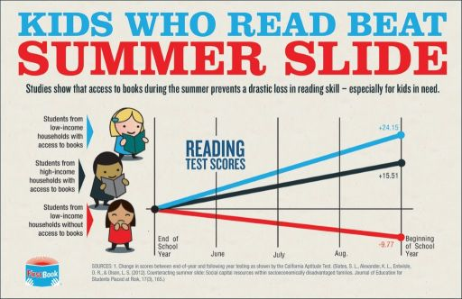

What is the Summer Slide?
Studies show and teachers will tell you: kids who don’t read over the summer come back reading at lower levels than when they left school in the spring. It often takes weeks to recover.
Let’s look at how we can prevent this, and actually increase students’ reading skills over the summer!

THE GOOD NEWS!!
Reading over the summer break helps all kids maintain or improve their reading. And it only takes a few hours a week. Just 30 minutes per day makes a HUGE difference!

According to Dominican University IMLS-funded research:

- The amount of time children spend reading outside of school is linked to gains in reading achievement. Numerous studies show that access to books and magazines is directly related to higher reading achievement.
- National research from Dominican University finds that students who participate in public library summer reading programs scored higher on reading achievement tests at the beginning of the next school year than those who did not participate.

How will I know if my children are reading at their just right level?

Kids enjoy reading (and are reading successfully) when they can do these 3 things well:

- Accuracy (figuring out what the words are)

- Comprehension (understand what words mean all together)

- Fluency (reading smoothly and with expression)

How to check their accuracy:
Listen to your child read a page or two.

They should be able to read the words correctly about 95% of the time.
That means that out of 20 words, they read 19 correctly. This is “just right.”

If it’s closer to 90% (18 out of 20 words read correctly) the book is at their “instructional level,” and they will need a little bit of help from a stronger reader (an older sibling, parent, friend).

If they make more errors than that, they will struggle to understand and may not ENJOY the reading. This is called the “frustrational level.”

How to check their understanding:
After your child has read a few pages/chapters, ask some questions.
Can they answer literal and inferential questions?

- Literal questions ask about what the text explicitly says. For example, “Whose house did Goldilocks go into?” “What did she eat?”

- Inferential questions require the reader to “read between the lines” and figure something out that isn’t directly said in the text. It requires deeper thinking. These are often “why” questions.

Examples:
“Goldilocks went into the 3 bears’ house without permission... What does this tell you about Goldilocks?”
“Why did the character do/say …”
“What do you think the character felt…” “How do we know?”
“How did the character change over time?” “How do you know?”

How to check for fluency

Listen to HOW your child sounds when they read aloud. (They may prefer reading silently most of the time, but just for the sake of checking in, have them read aloud for a bit)
The key here is that the reader can read smoothly. This starts with chunking words together into phrases. It also involves:
- reading in phrases that make sense together,
- taking pauses in places that don’t interrupt the meaning.
- reading with voice/expression.
- pausing appropriately after periods and commas

If this is hard to do, it may be because the book level is too high. To improve fluency, have your child reread much loved books, and practice reading books at a lower level focusing on “reading like we talk.”

Finding “Just Right” books

You DO NOT need to go and spend money buying a bunch of just right books. The public library is sure to have many. And kids often know friends with books they can borrow. The question is, what are the RIGHT books to choose at the library?

(Of course, if you do want to buy your child a book, make it one they will read over and over! That repetition builds fluency!)

Here are some ways to find titles of books that are at the right level:

http://www.readingrockets.org/books/choosing-and-using-kids-books
Tips for choosing books for children. Information about reading aloud to your kids.
Looks like a great site!

A list of books by level (pdf)
http://www.enterprisecharter.org/content/Books/leveled_book_list.pdf

Google search: books for kids level __
Select goodreads.com page. If you go to the HOME page, searching by level is difficult.
By using the google search your result should look like this:
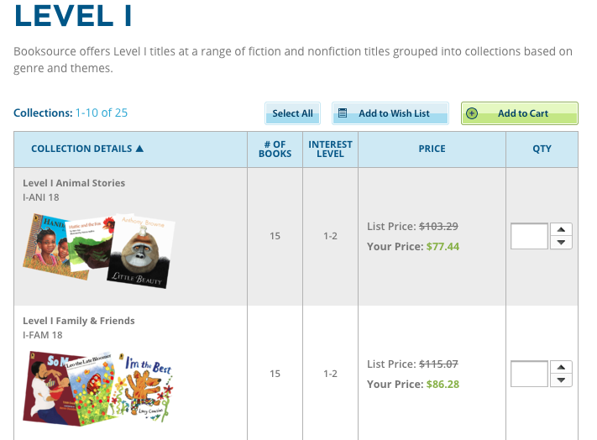

Incentives and supports

Berkeley Public Library
Summer Reading Game
www.berkeleypubliclibrary.org/sites/default/files/2017_game_card-child.2.pdf

Alameda County Office of Education
Storyland: A Family Literacy Festival
Saturday, June 16, 2018 in Hayward
Sign up at: www.storyland2018.eventbrite.com

Flocabulary Summer Engagement Activities
There’s a whole packet of ideas.
I can make copies and create an account for your child.
Also, your child can watch academic videos about math, history, science, life skills all presented in short raps. There are short quizzes they can take afterwards to show what they learned. Tutorials show them how to create their own raps.
www.flocabulary.com
flocabulary.com/week-in-rap-contest (grades 6-12)
flocabulary.com/week-in-rap-junior-contest (grades 3-5)

HOLD THEIR SCREENS AND DEVICES HOSTAGE!!
Make a list of requirements before they can have screen time! You can make a poster to remind kids of all the things that need to be done before watching tv, playing video games, etc.

For example:

Before asking to use an electronic device, be sure you have:
- Brushed your teeth
- Finished your chores (list them!)
- Read for 30 minutes

If they complete their tasks, give them a LIMITED amount of time on electronics. If they want more time, give them more jobs!
Other fun activities:
LEGO time in the Library
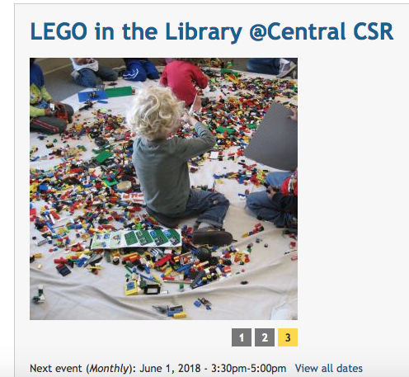

Computers for Kids

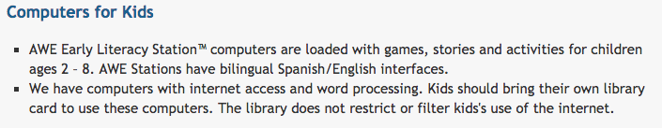
Discover and Go discounts

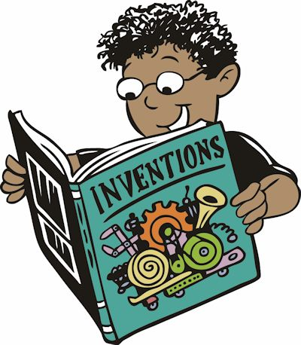
Activities to Help Prevent “Summer Slide” 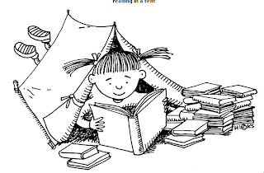
Reading
Join the Berkeley Library Summer Reading Program
Listen to audiobooks on Tales to Go. Log in as SCHOOL User ID = firstnamelastname
Password = tales
Watch actors read stories at www.storylineonline.net

Writing
Keep a journal. Write about stories you are reading and/or your experiences.
Write letters or e-mails to friends, teachers, and/or family members.

Math
Have a lemonade stand or garage sale and practice your money skills.
Bake and cook with family or friends to practice your fractions. Try doubling or cutting recipes in half.
Play math games with dice and/or a deck of cards. http://www.educationworld.com/a_lesson/archives/boxcars.shtml

Social Studies and Science
Before taking your vacation, research the destination’s history, culture, customs, and landmarks.
Get free (or discount) tickets to museums, such as Lawrence Hall of Science, through Discovery and Go. www.berkeleypubliclibrary.org/explore/discover-go
Do at home science experiments. Find ideas at https://sciencebob.com/category/experiments/
Compiled by Kathleen Marte, Thousand Oaks Elementary ELD Site Coordinator

Another service of the Library:
