_________________’s Summer Reading Log

Today a Reader,
Tomorrow a Leader!

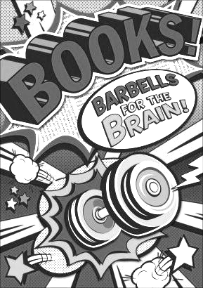
Yeah! It’s summer! We know summer can be a busy time for families. Any Washington student knows that we work hard at building our reading muscles all year long. In class, we spend time reading, thinking about our reading, and talking about our reading. Research shows that reading over the summer helps keep our reading muscles in shape.

This year choose any 6 or 7 weeks (Of course, you can always read more!) during the summer to fill in your log. There are no required minutes. Just read as much as you can!

2 Easy Ways to Make Summer Reading Fun:

- Student Choice is Important.
  - Students are more motivated when they self-select their own books.

- Read-Alouds Count on the Reading Log.
  - Parent, caregivers, and older siblings can read aloud to your student(s). Reading is more fun when shared. ♥♥♥

----------------------------------------------------------------------------------------------

Bring your Summer Reading Log back at the beginning of school in the Fall so your teacher can see all the interesting books you read over the summer.

Happy Summer Reading!

_____________________’s Reading Log

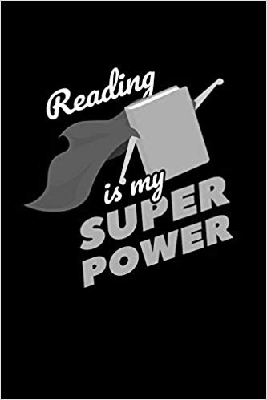
Pick any 6 or 7 weeks during the summer to fill in your log.

Week of _____________________________

Date | Title of book | Minutes | Rate your book (circle one)
 |  |  | ☺ OK ☹
 |  |  | ☺ OK ☹
 |  |  | ☺ OK ☹
 |  |  | ☺ OK ☹
 |  |  | ☺ OK ☹
Total minutes: _______

Week of ______________________________

Date | Title of book | Minutes | Rate your book (circle one)
 |  |  | ☺ OK ☹
 |  |  | ☺ OK ☹
 |  |  | ☺ OK ☹
 |  |  | ☺ OK ☹
 |  |  | ☺ OK ☹
Total minutes: _______

Week of ______________________________

Date | Title of book | Minutes | Rate your book (circle one)
 |  |  | ☺ OK ☹
 |  |  | ☺ OK ☹
 |  |  | ☺ OK ☹
 |  |  | ☺ OK ☹
 |  |  | ☺ OK ☹
Total minutes: _______

Week of ______________________________

Date | Title of book | Minutes | Rate your book (circle one)
 |  |  | ☺ OK ☹
 |  |  | ☺ OK ☹
 |  |  | ☺ OK ☹
 |  |  | ☺ OK ☹
 |  |  | ☺ OK ☹
Total minutes: _______

Week of ______________________________

Date | Title of book | Minutes | Rate your book (circle one)
 |  |  | ☺ OK ☹
 |  |  | ☺ OK ☹
 |  |  | ☺ OK ☹
 |  |  | ☺ OK ☹
 |  |  | ☺ OK ☹
Total minutes: ________
Week of ______________________________

Date | Title of book | Minutes | Rate your book (circle one)
 |  |  | ☺ OK ☹
 |  |  | ☺ OK ☹
 |  |  | ☺ OK ☹
 |  |  | ☺ OK ☹
 |  |  | ☺ OK ☹
Total minutes: _______

Week of _______________________________

Date | Title of book | Minutes | Rate your book (circle one)
 |  |  | ☺ OK ☹
 |  |  | ☺ OK ☹
 |  |  | ☺ OK ☹
 |  |  | ☺ OK ☹
 |  |  | ☺ OK ☹
Total minutes: _______

Hooray! I read as much as I could during the summer!

Student Name __________________________________________

Parent Signature __________________________________________

